|  |  |
| --- | --- |
| User Decoumentation  Restaurant | Abstract  Gone Sin (going down from high places without making any own efforts)  By Bit Geek |

# Introduction

Gone Sin Mal is a mobile platform for all restaurants or food shops which allows them to host their information. Moreover, they can even use the coin system provided by the platform to promote the sales or attract the customers.

As for the restaurant side, they will get many costumers since they will be giving promotion coins. For the benefit, they can refund those coins that are used by the customers, so they don’t lose money by buying those coins and giving it to customers. Moreover, since the special promotion coins can be used only on the particular restaurant, the customers who got that promotion coins will sure come and eat at the restaurant. This promotion system is well suited for newly start-up restaurants.

# Navigation Bar

This is the navigation bar of the restaurant where you can navigate to another screen or pages of the app.

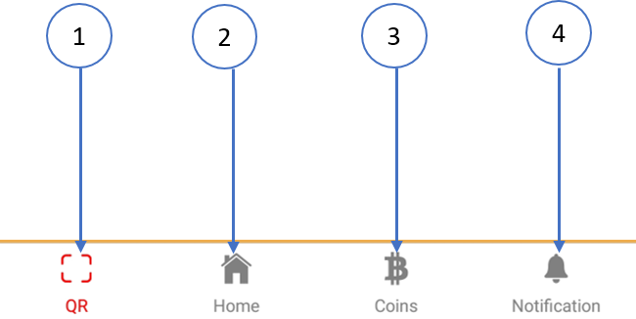

1. You can scan QR code to give and get coins from customer by clicking QR button
2. You can view restaurant information by clicking Home Button
3. You can buy or refund coins by clicking Coins button
4. You can view the notification message by clicking the notification button

# Restaurant Register Page

For the restaurant register page, you can see the different text filed to fill and Logo of the restaurant.

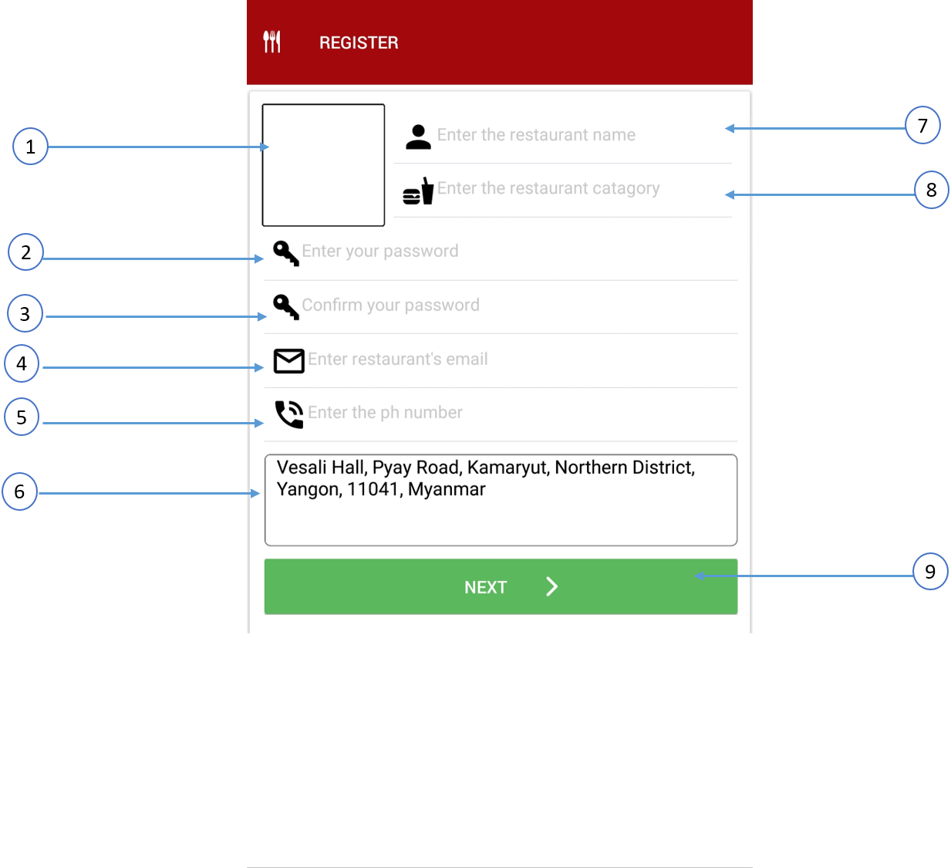

1. You must choice from your gallery to add the logo of the restaurant
2. You must fill the password for your restaurant
3. Enter Confirm password again same with no.2 text field of password
4. You must enter the email of the restaurant as valid email format like [kfc@gmail.com](mailto:kfc@gmail.com)
5. You must register the phone number for the restaurant with valid format like 091234567
6. For the address text filed, click that text field and you just need to drop the pin to google map
7. You must enter the name of the restaurant
8. You must fill the categories of the restaurant
9. If you click the next button, you will reach the register home page and view the restaurant information

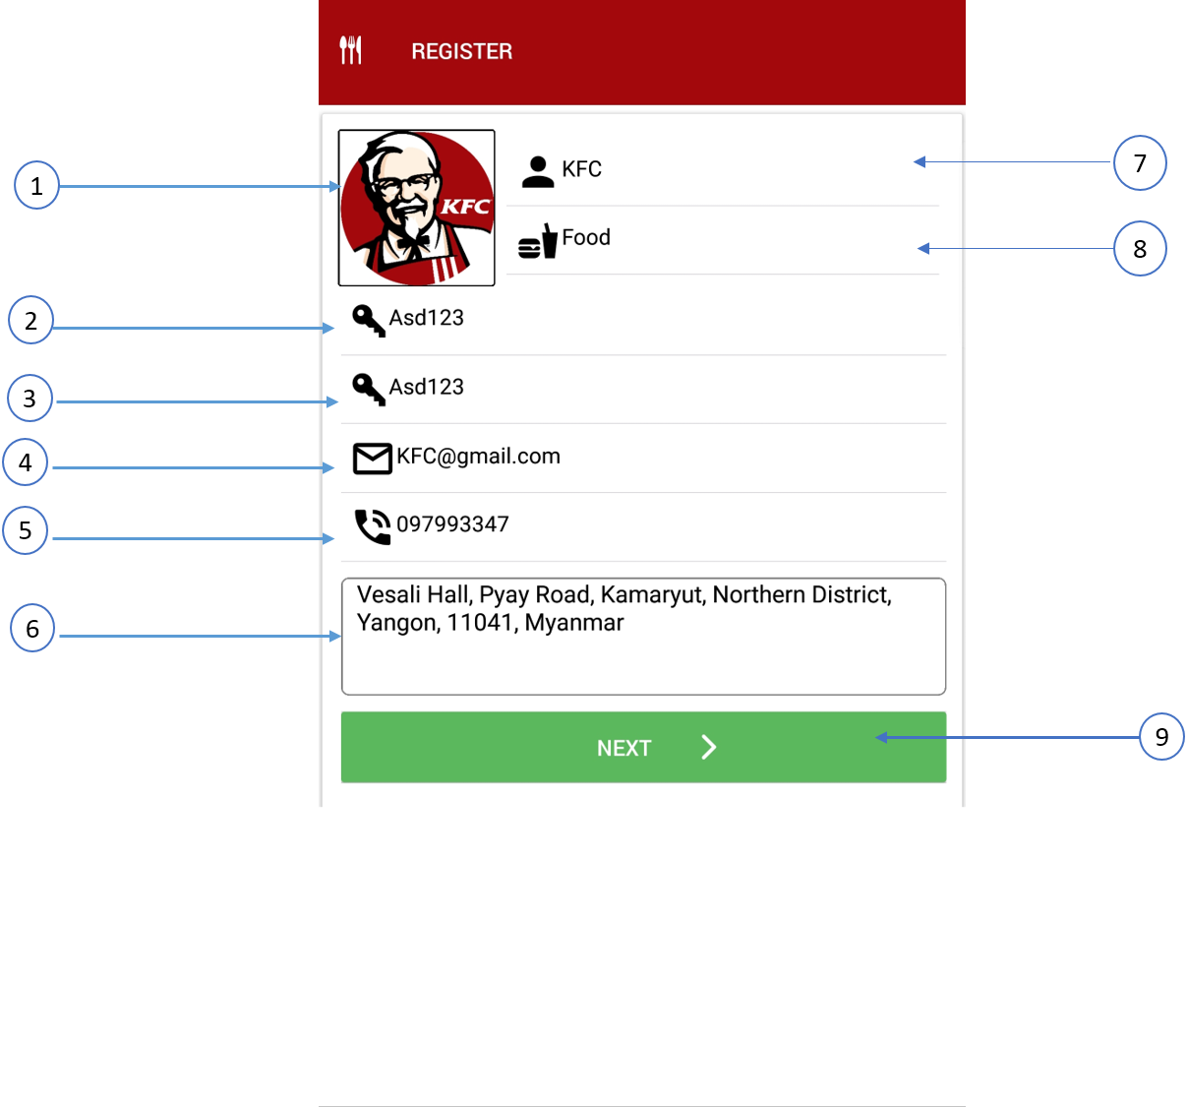

# Home

This is the Home page of the restaurant and you can view and edit the restaurant information.

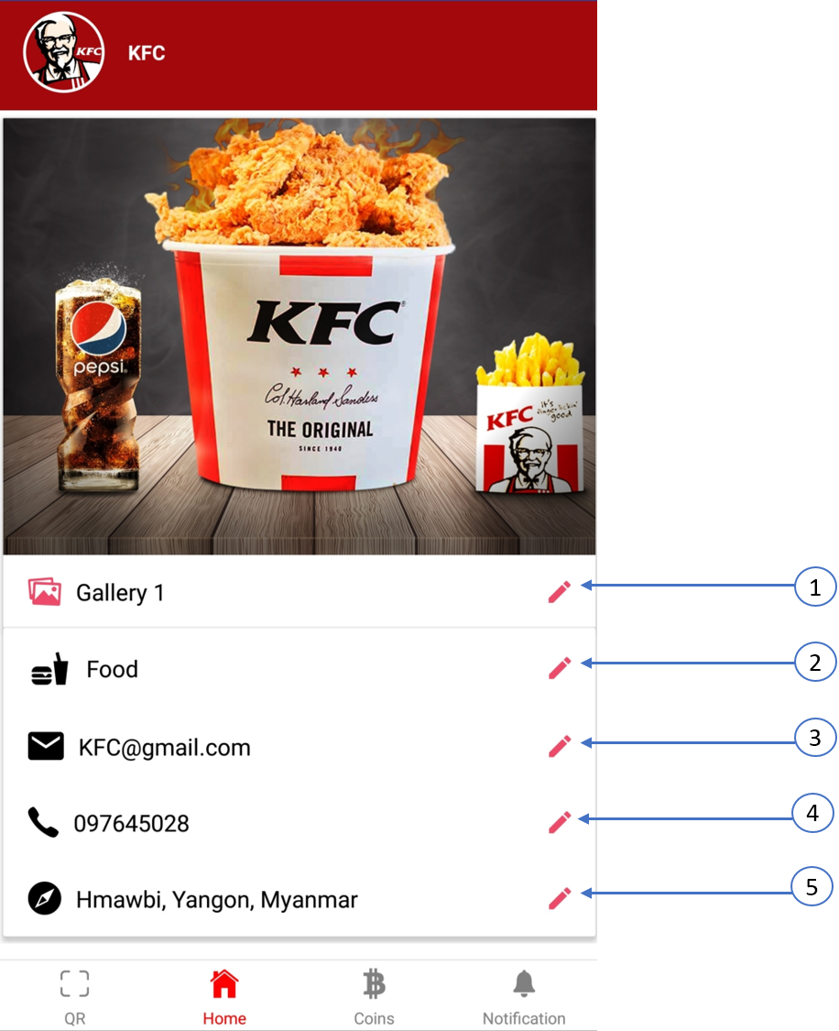

1. You can edit or add the image of the restaurants by clicking the edit button (pencils)
2. You can edit categories of the restaurants by clicking the edit button (pencils)
3. You can edit Gmail of the restaurants by clicking the edit button (pencils)
4. You can edit phone number of the restaurants by clicking the edit button (pencils)
5. You can edit location the restaurants by clicking the edit button (pencils)

# Coins Page of the Restaurant

You can see the various coins package to buy and also refund the coins.

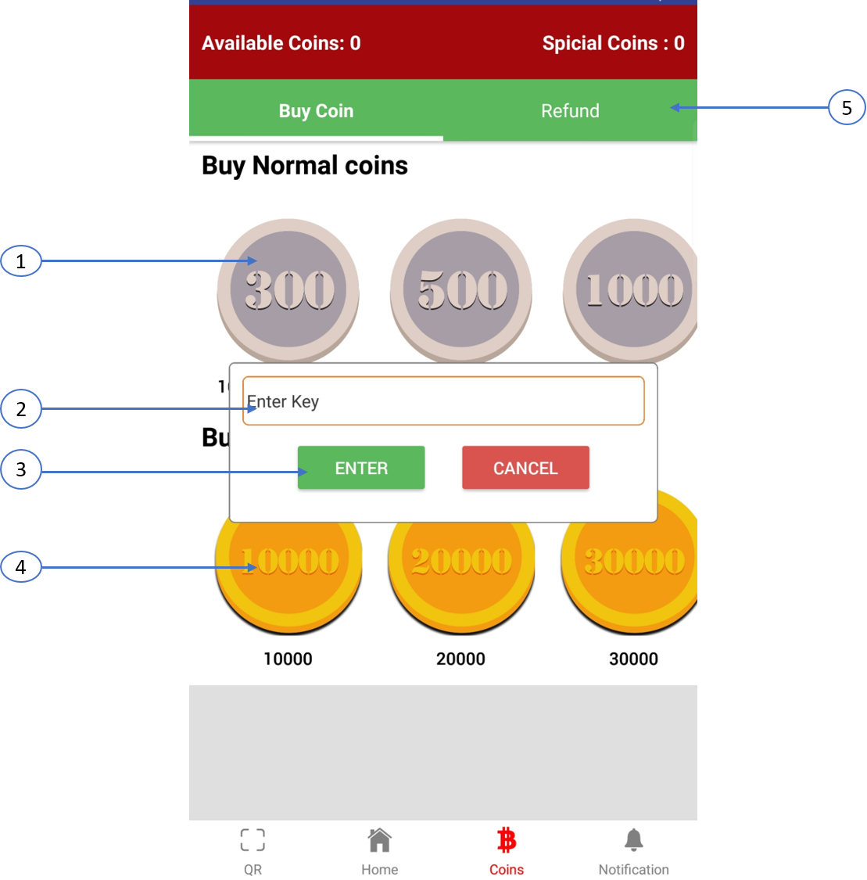

1. Clicking the normal coins (silver coins) button can buy coins using MyanPay account
2. You must enter your restaurant password correctly to do other functions like buying coins or refund
3. If you enter valid password key, you have access to do other function
4. Clicking the special coins (gold coins) button can buy coins using MyanPay account

# Notification Page (Normal Coin)

You can view the notification message such as buying normal coins or special coins.

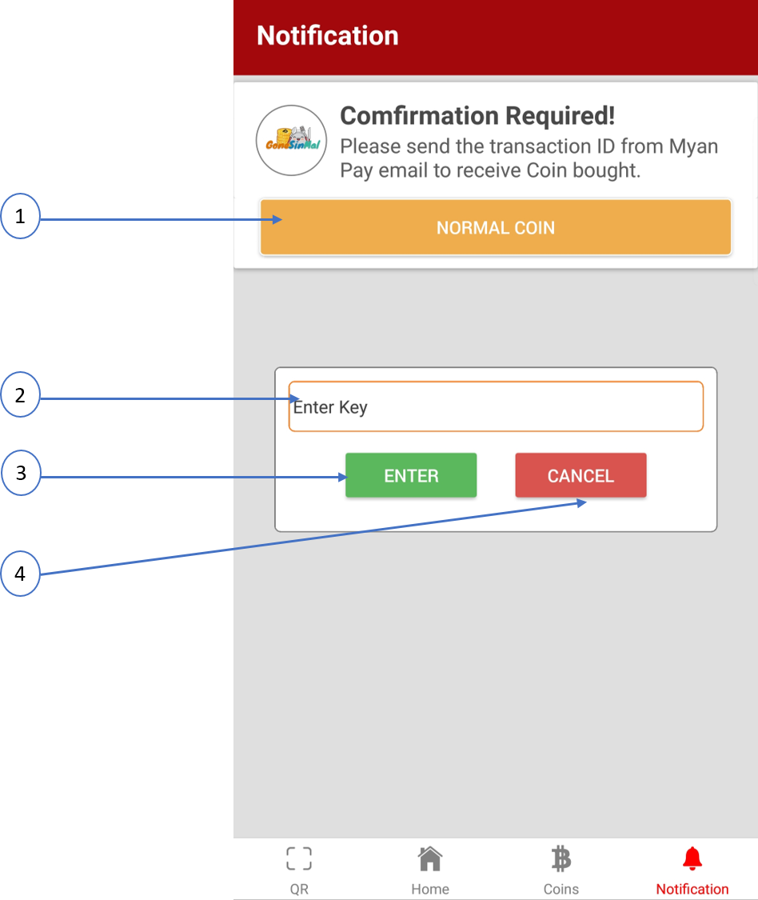

2. First you must enter your password to get access to do other functions

3. Clicking enter will success permission to do other things if you enter the correct password

4. Clicking cancel will fail the permission and you access will be denied if you do other things that exist in that page

1. You can reach to Myan pay page and confirm the buying coins process by clicking normal button

# Confirm Notification

If you enter your transaction ID that exist in inbox of your email that sent from Myan pay. If the transaction ID is valid, you will get the notification and see this message as shown in below.

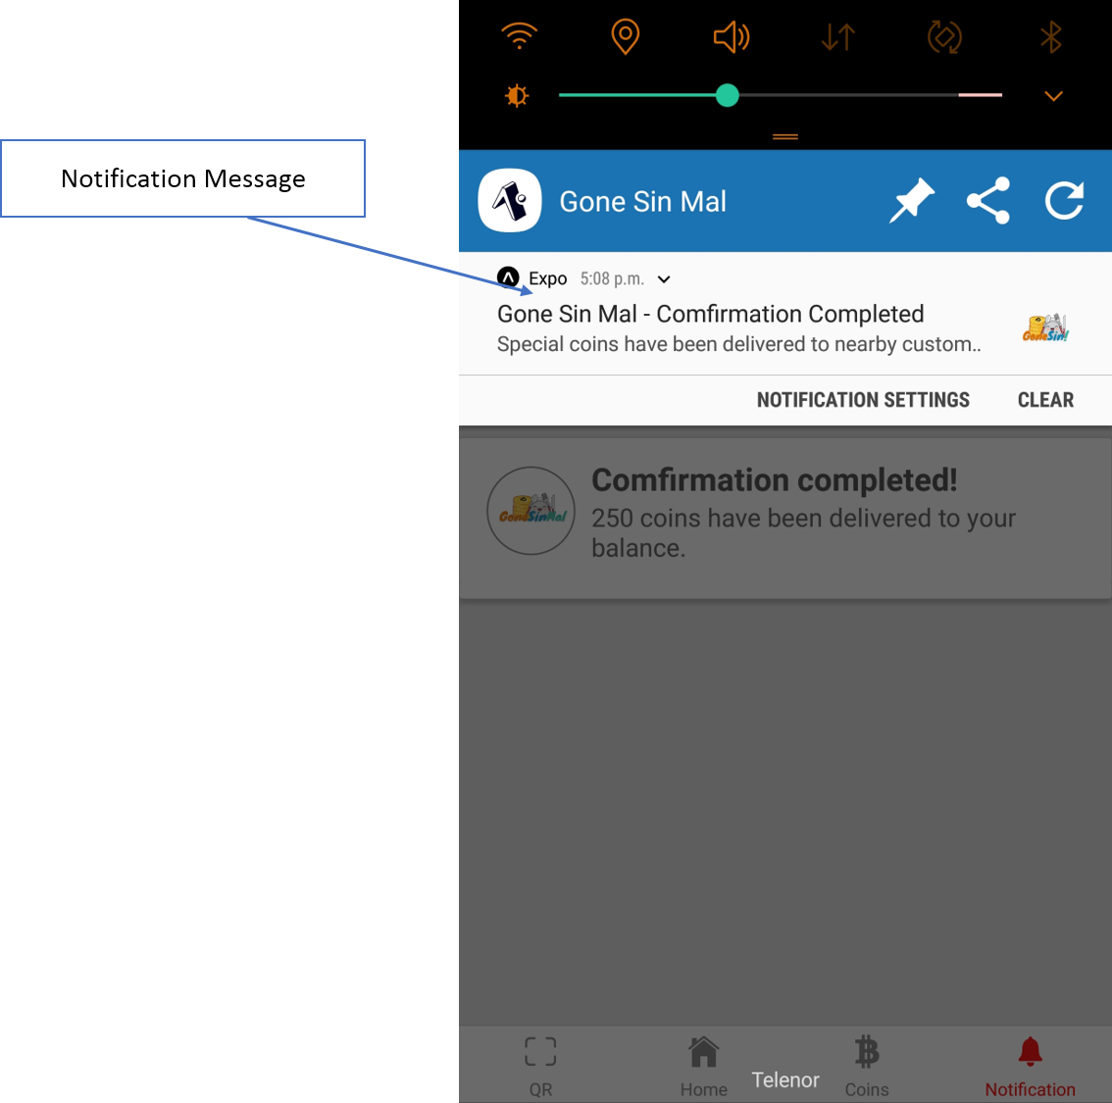

# Myan Pay Page

You must enter your username and password to log in to Myan Pay and get the online payment functions of Gone Sin Mal app.

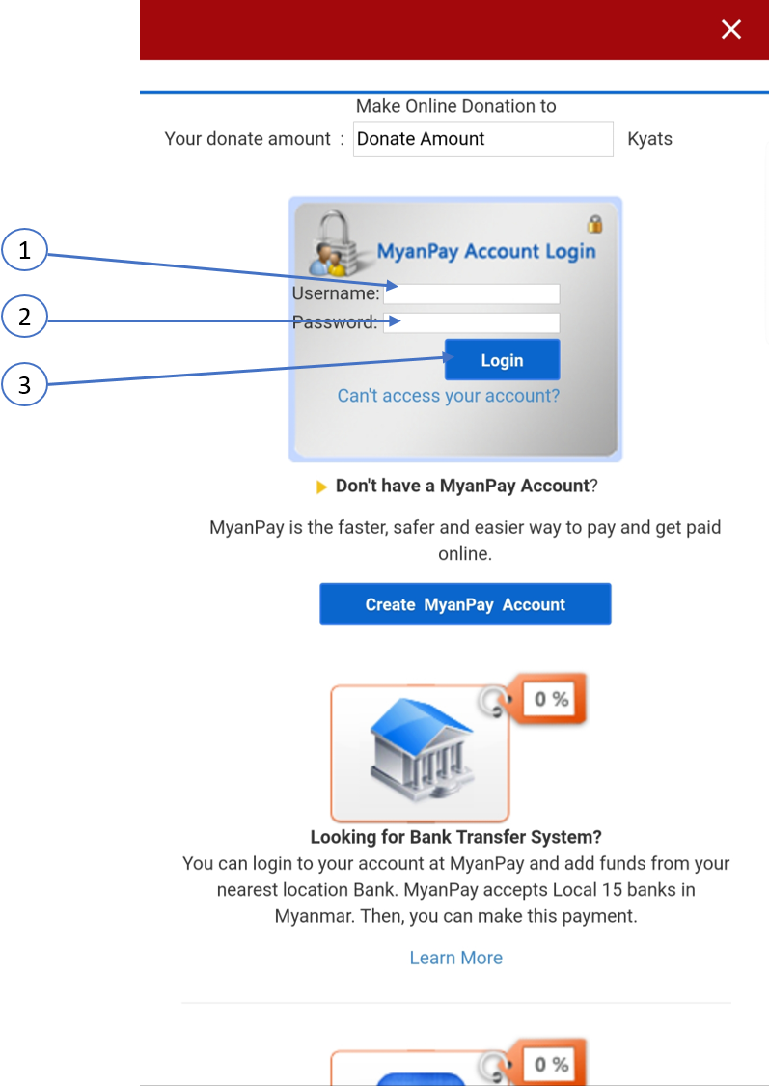

1. You must enter your Myan Pay account’s username
2. You must fill your password that you register in Myan Pay
3. Click log in button to get the coins package from Gone Sin Mal app

# Transaction ID for coins package purchase

If you purchase one of the coins package from Gone Sin Mal, you need to fill the correct Transaction ID to get the online payments services using Myan Pay.

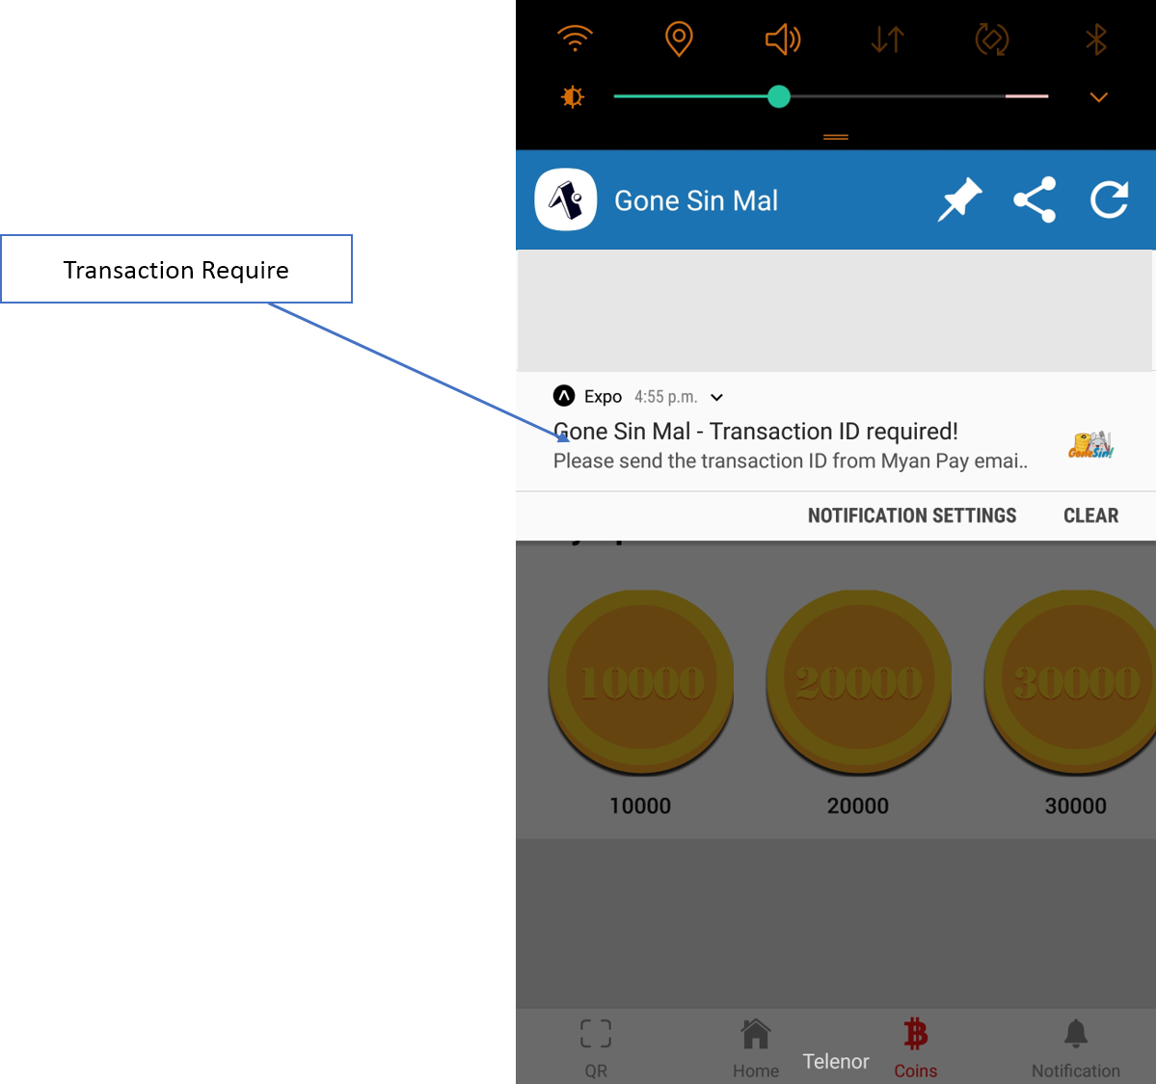

# Notification Page (Special Coin)

You can view the notification message such as buying normal coins or special coins. Special coins can give directly to customer as free coins.

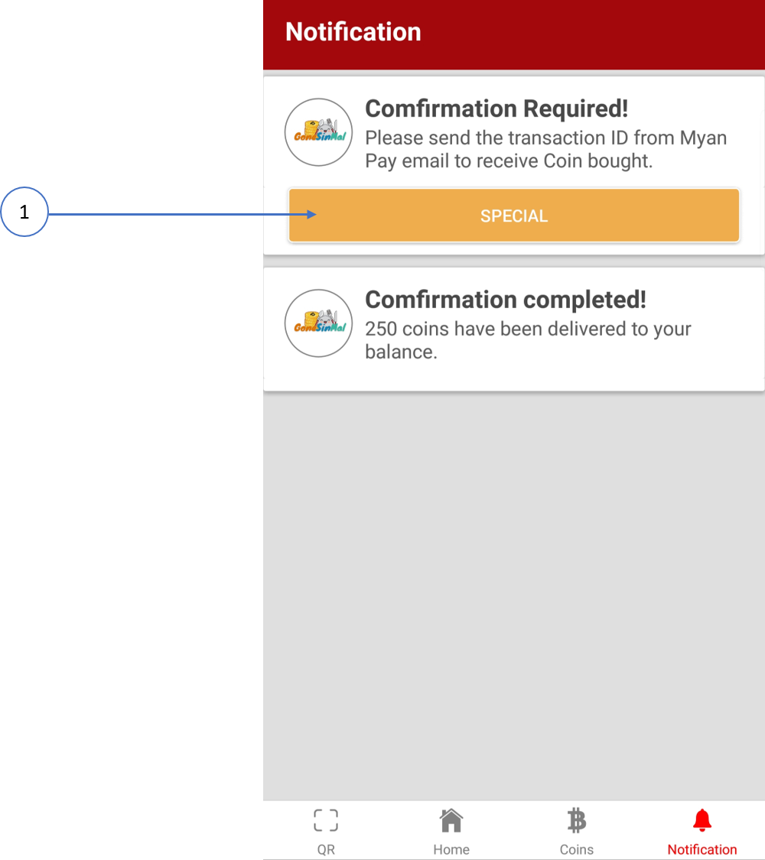

1. You will get text box to fill number of user and transaction ID by clicking special button

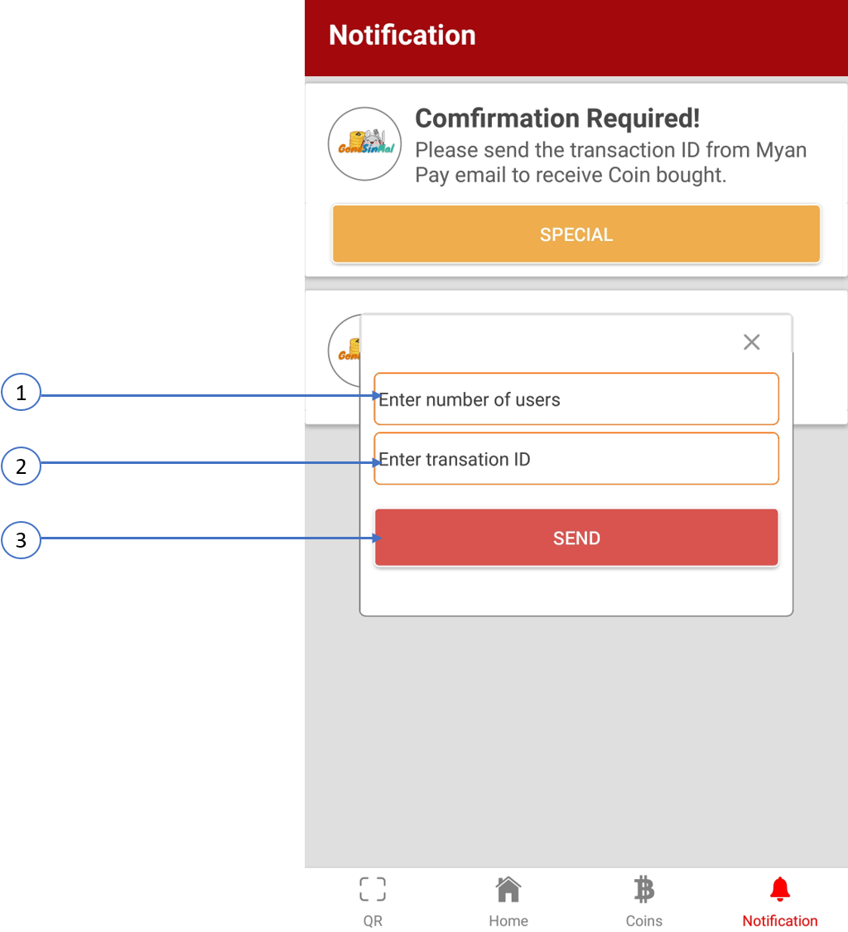

1. You must enter the number of users that you want to give free coins or special coins
2. You must fill transaction ID to give special coins to customer
3. Clicking send button will send the special coins that you purchase to customer

# QR Scan

You can view the scanner for QR to give coins to customer, get coins from customer and coins amount text fields that you want to take or give.

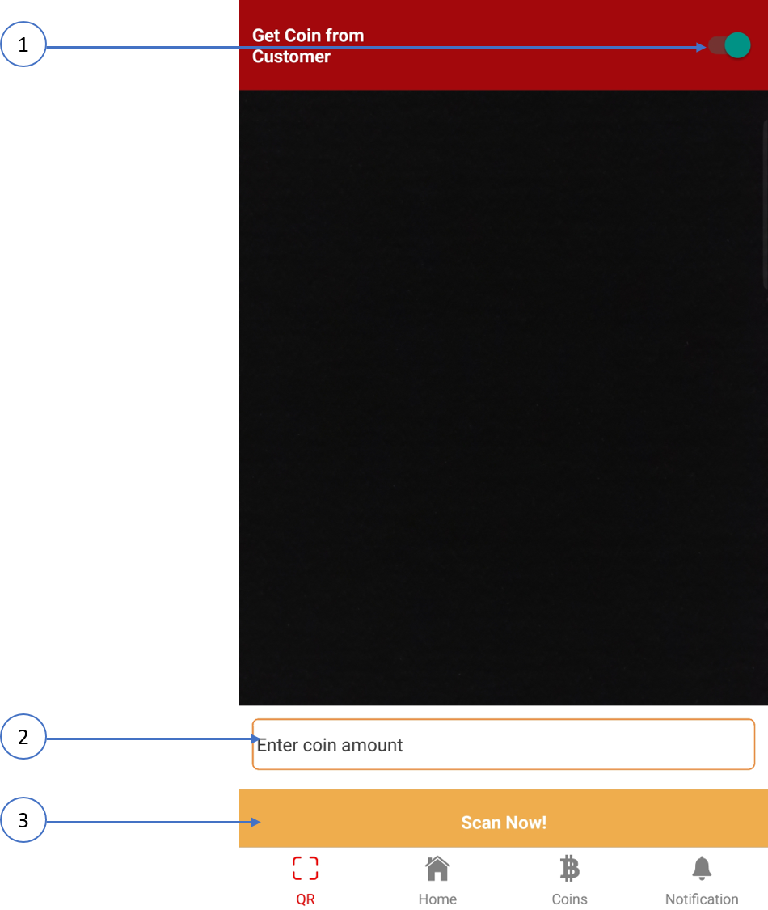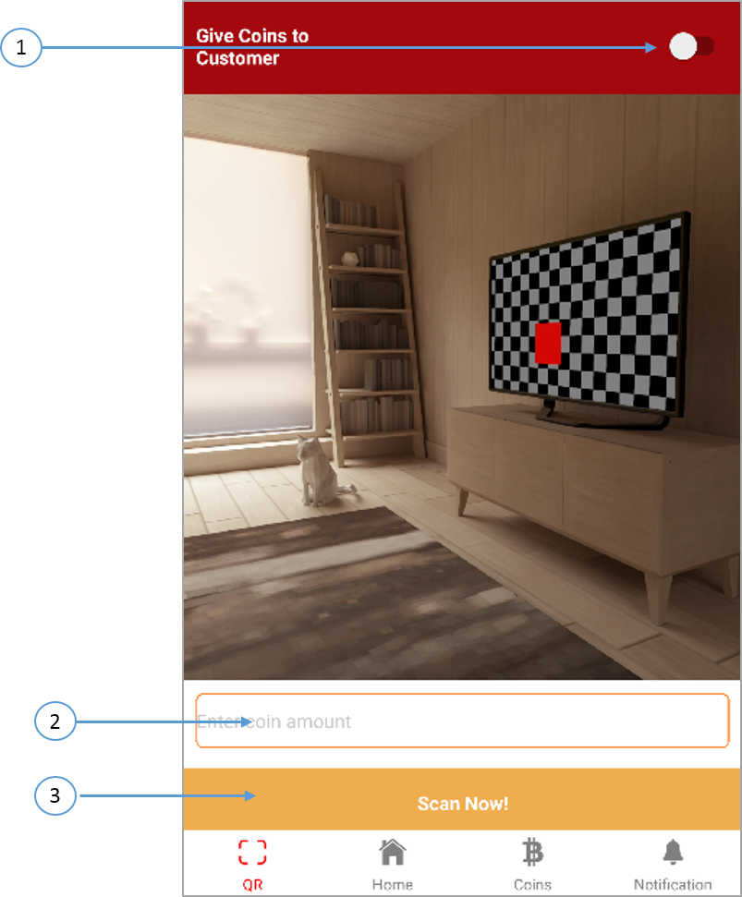

1. You can change the functions like give coins and get coins
2. You must enter coins amount that you want to take or give and scan the customer’s QR Code
3. It can give and get coins by clicking Scan Now! Button

# Gone Sin (Scan for Special Coin)

Gone Sin Mal have other functions for special coins that give from specific restaurant to customer as free coins. It’s also works as QR Scanner like normal coins, but it doesn’t need to enter the amount of coins. If you scan the QR code that exist in customer Gone Sin List, you will get the alert message as shown in below.

